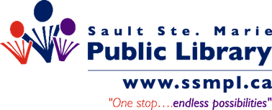
Newly Added Non-Fiction
March 2024

Autobiographies, Biographies and Memoirs
Allahdua, Gabriel. Harvesting Freedom: The Life of a Migrant Worker in Canada. Available
Bhatia, Nav. Heart of a Superfan: A Memoir of Grit, Love, Family and Basketball. Coming soon!
Blackstock, Uché. Legacy: A Black Physician Reckons with Racism in Medicine. Coming soon!
Douglass, Frederick. The Narrative of the Life of Frederick Douglass, an American Slave. Coming soon!
Hefner, Crystal. Only Say Good Things: Surviving Playboy and Finding Myself. Coming soon!
Helmuth, Diana. The Witching Year: A Memoir of Earnest Fumbling Through Modern Witchcraft. Available
MacLean, Tara. Song of the sparrow. Available
McLaughlin, Sydney. Far Beyond Gold: Running from Fear to Faith. Coming soon!
Solomon Northup. Twelve Years a Slave By: Solomon Northup. Available
RuPaul. The House of Hidden Meanings: A Memoir. Coming soon!
Shoalts, Adam. Where the Falcon Flies: A 3,400 Kilometre Odyssey From my Doorstep to the Arctic. Available
Sinclair, Christine. Playing the Long Game. Available
Washington, Booker T. Up from Slavery: An Autobiography. Coming soon!

Business, Economics and Finance
Posadzki, Alexandra. Rogers v. Rogers: The Battle for Control of Canada's Telecom Empire. Coming soon!
Robbins, Anthony. The Holy Grail of Investing: The World's Greatest Investors Reveal Their Ultimate Strategies for Financial Freedom. Coming soon!
Vettese, Frederick. Retirement Income for Life: Getting More Without Saving More (Third Edition). Coming soon!

Food and Drink

Ashmore, Kat. Big Bites: Wholesome, Comforting Recipes That Are Big on Flavor, Nourishment, and Fun: a Cookbook. Coming soon!
Ben-Ishay, Melissa. Come Hungry: Salads, Meals, and Sweets for People Who Live to Eat. Coming soon!
Downey, Robert, Jr. Cool Food: Erasing Your Carbon Footprint One Bite at a Time. Coming soon!
Muhlstein, Ilana. Love the Food That Loves You Back. Coming soon!

Health & Wellness
Gundry, Steven R. Gut Check: Unleash the Power of Your Microbiome to Reverse Disease and Transform Your Mental, Physical, and Emotional Health. Coming soon!
Gunter, Jen. Blood: The Science, Medicine, and Mythology of Menstruation. Coming soon!
Mukherjee, Siddhartha. The Song of the Cell: An Exploration of Medicine and the New Human.
Available

History
Hendley, Nate. Atrocity on the Atlantic: Attack on a Hospital Ship During the Great War. Available
Hylton, Antonia. Madness: Race and Insanity in a Jim Crow Asylum. Coming soon!

Indigenous

Ratt, Solomon. Kâ-pî-isi-kiskisiyân = The Way I Remember. Coming soon!

Literary
Sharpe, Christina Elizabeth. Ordinary notes. Available

Mental Health
Kilcoyne, Karena. Rise above the Story: Free Yourself from Past Trauma and Create the Life You Want. Coming soon!

Project Management
Flyvbjerg, Bent. How Big Things Get Done: The Surprising Factors that Determine the Fate of Every Project, From Home Renovations to Space Exploration and Everything in Between. Available

Psychology
American Psychological Association. Concise Guide to APA Style: 7th Edition (OFFICIAL). Coming soon!

Poetry
Bouchard, Joshua Chris. Burn Diary: Poems. Available

Pop Culture
Kennedy, Kate. One in a Millennial: On Friendship, Feelings, Fangirls, and Fitting In. Coming soon!
Woolman, Clyde. Growing up Canadian: Canada and Its Youth Come of Age 1960-1980. Coming soon!

Self-Help
Clear, James. Atomic Habits: Tiny Changes, Remarkable Results: An Easy & Proven Way to Build Good Habits & Break Bad Ones. Available

Sociology
Craigie, Gregor. Our Crumbling Foundation: How We Solve Canada's Housing Crisis. Coming soon!
Du Bois, W. E. B. The Souls of Black Folk. Coming soon!
Gupta, Arun. Venture Meets Mission: Aligning People, Purpose, and Profit to Innovate and Transform Society. Coming soon!
Ricketts, Rachel. Do Better: Spiritual Activism for Fighting and Healing from White Supremacy. Available

Spirituality
Arthur Riley, Cole. Black Liturgies: Prayers, Poems, and Meditations for Staying Human. Coming soon!
Skoog, Ryan. Lead with Prayer: The Spiritual Habits of World-Changing Leaders. Coming soon!

True Crime
Douglas, Norm. You Be The Judge. Coming soon!

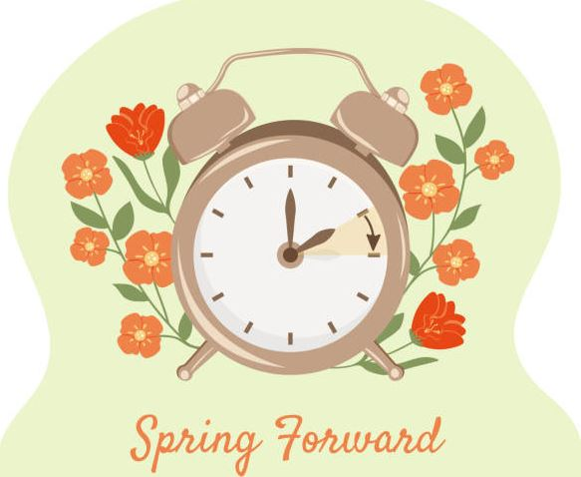

Additional information on these titles is available on the library’s home page @ ssmpl.ca

Reading and Entertainment+

Catalogue
or

Recommended Reads

or call Reference and Information @ 705-759-5236

